Docker Tasks

First Task
- Create a docker container using busybox.
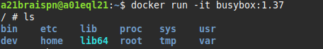

- Create two files within busybox.
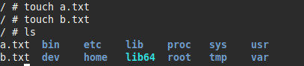

- Create a new image with the updated container. Call this image your_user/busybox.
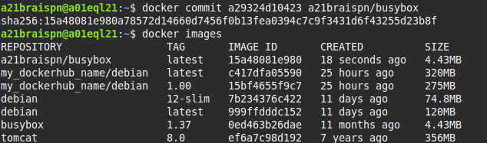
- Create and run a container using this new image. Connect to this container and check that the files you had created are in this image.
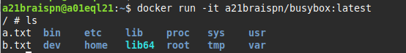

- Check the images and containers running on your system.
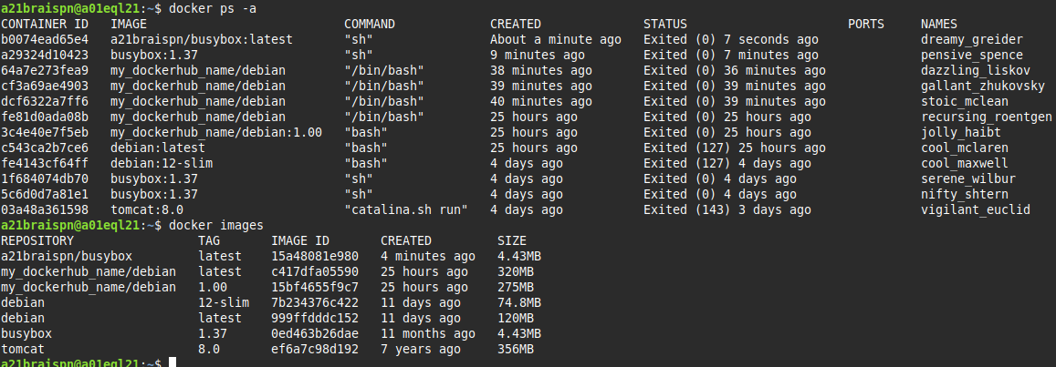
- Delete the image and the container.
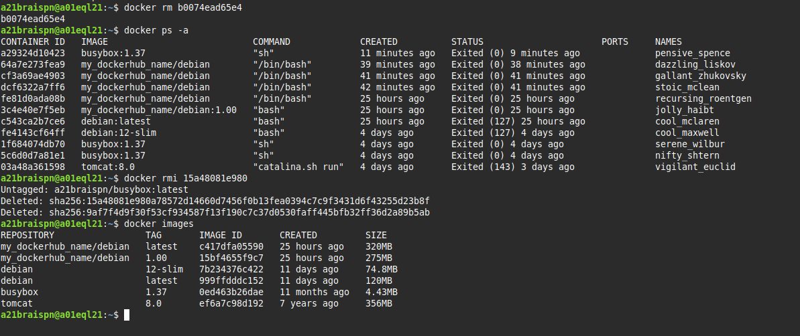

Second Task
- Create a Dockerfile that does the previous tasks.
FROM busybox:1.37
RUN touch /a.txt /b.txt
CMD ["sh"]

- Create a new image called your_user/busybox and run the container.
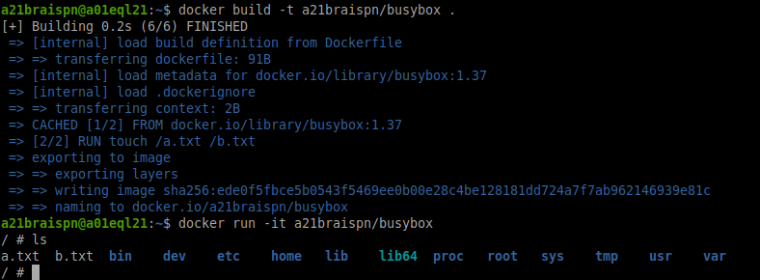
- Check the images and containers running on your system.
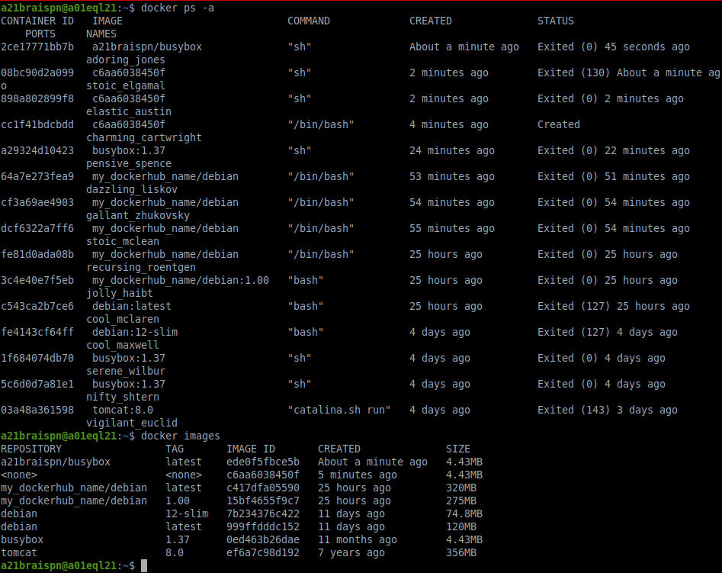

- Delete the image and the container.
